Frère Jacques

Introduction
In this activity you will place blocks in the correct sequences and subroutines to play the song Frère Jacques.

Open the Frére Jacques (ncce.io/prg1-fj) Scratch program.

Work in pairs as directed by your teacher to complete the tasks below.

Task 1: The Frère Jacques sequence

Move the blocks into the correct sequence so that the lyrics to the song Frère Jacques are in the correct order. The first one has been done for you.  To help you, try listening to the melody again. Your teacher will have placed this in a shared area for you to access. | 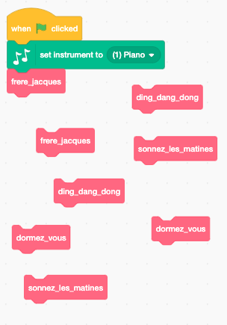

Task 2: Make your subroutines

Listen to each block of music sequences (the green blocks) by using a single click on the block.  Place the sequence under the appropriate subroutine headings. | 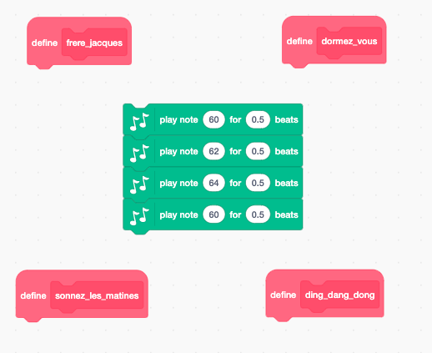

Task 3: Listen to your music

Now press on the Green flag on the top right-hand side of the screen to listen to your program play. | 

Explorer Tasks

Task 4: Make a round

A round is to play or sing the same melody but start at different times. Frère Jacques is perfect for this. The second instrument would start playing once the first instrument has finished the first two lines of Frère Jacques.

4.1: Make a second instrument

The first task is to ‘duplicate’ the piano and all of the code that you have placed into the correct sequence. | 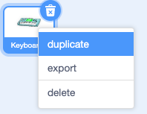

4.2: Broadcast messages

Through Scratch you can use the Broadcast block to send a message out to other sprites in your program that can prompt them to run code.  Make sure that you have selected your first keyboard sprite, then click on the Events button on the left-hand menu and drag Broadcast message1 into your program.  You need your program to broadcast a message when you would like the second instrument to start. Place the broadcast block into your code where you would like this to happen.  Hint: Read the paragraph at the start of the activity to help |   

4.3: Use broadcast to tell your second keyboard when to start

Select your second keyboard.  Remove the When green flag is clicked block. Be careful to only remove this block and not the blocks attached below it.  Hint: To do this, you will first need to click and drag the Set instrument to (1) piano block away from it and then drag the Green flag block off to the left-hand side of the screen back into the commands panel.  Replace the Green flag block with the When I receive message1 block. | 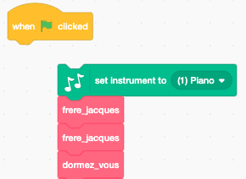  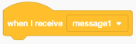

4.4: Run your program

Run your program and listen.  Has it worked?  If not, go back to your first keyboard. Are you broadcasting in the correct place?  If it did work, try adding in a third piano.  Hint: You will need to broadcast a different ‘message 1’. You can create a new message by clicking on the Drop-down arrow next to ‘message1’. | 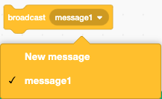

Resources are updated regularly — the latest version is available at: ncce.io/tcc.

This resource is licensed under the Open Government Licence, version 3. For more information on this licence, see ncce.io/ogl.

